**Report: TEQ - Experiment meetings November & December 2021 – online**

**Purpose of meeting:** To focus all partners effort for the ultimate TeQ experiment at UoS and at low temperature (300 mK). We have weekly meetings (Tuesdays at 11 am UK time for 60 minutes duration) to update on electronics, Paul trap and adaptation to cryostat, as well as on the detection mode for the final experiment (based on state estimation and quantum Fisher information metrology tools) based on theoretical expertise within the TeQ consortium. The meeting have no formal structure but a regular update in the following topics:

1. The electronics boards from INFN to provide low-noise AC and DC power supplies for the TeQ Paul trap specifications.
2. Configuration of Paul blade trap at UCL with low-noise electronic, at UHV conditions and at room temperature. The configuration is informed by the needs to eventually home the trap at UoS in the cryo. Room temperature tests are planned for January 2022.
3. Preparation of the cryostat at UoS to receive the Paul trap in early February 2022 and to conduct low temperature experiments.
4. Magnetic levitation experiments at UoS to reach the TeQ objective to test CSL.
5. Develop and apply to data a single trajectory based detection scheme for the TeQ experiment to avoid the long timescales of thermalization of the particle motion to the environment by QUB.

**Location:** online via zoom.

**Meeting dates:** 23/11/2021, 30/11/2021, 07/12/2021, 14/12/2021

**Participants:** Catalina Curceanu, Michael Drewsen, Peter Barker, Thomas Penny, Jonthan Gosling, Massimiliano Bazzi, Chistopher Timberlake, Antonio Pontin, Andrea Vinante, Matteo Carlesso, Mauro Paternostro, Hendrik Ulbricht

**Status quo:**

* 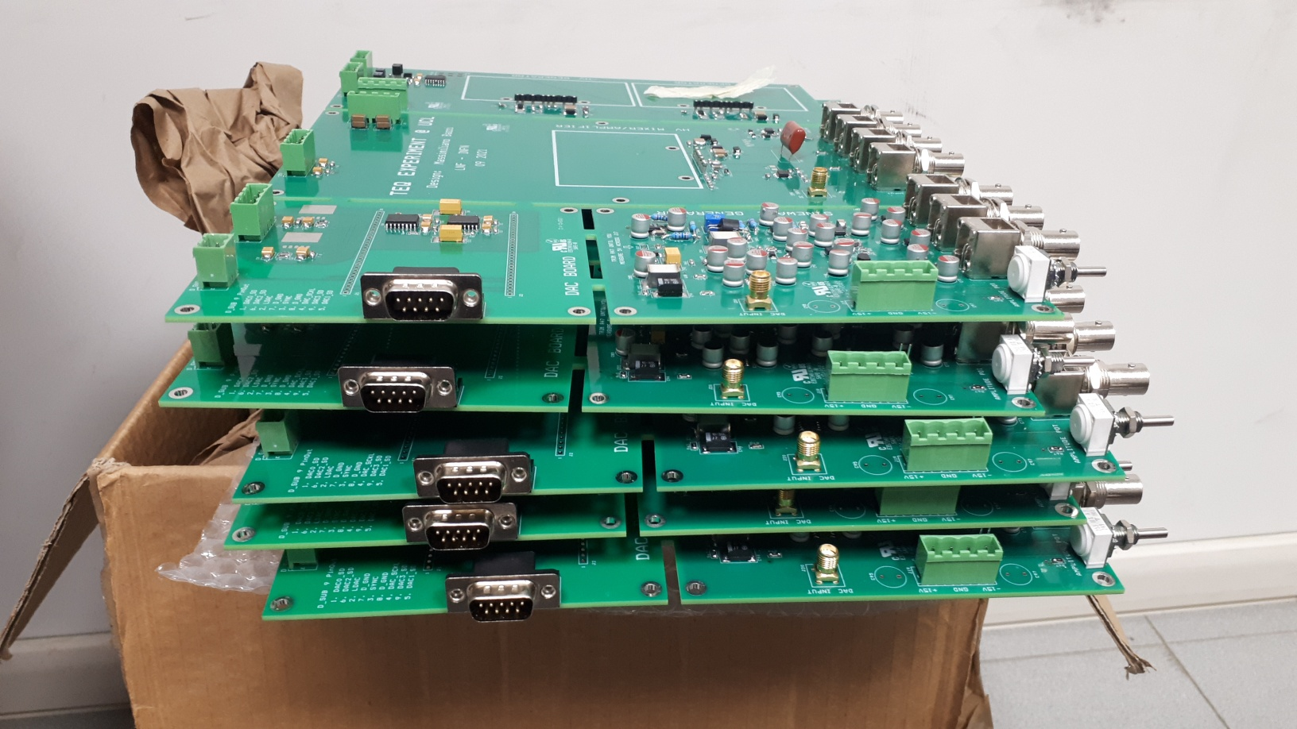To 1): INFN have designed and tested the final version of the TeQ electronics, **c.f Fig.1**. All devices are on a single PCB board to avoid noise coupling into connection lines. 4 PCB boards have passed the quality check and have been shipped to UCL, where they will be assembled into an electronics box with in- and outputs. One more board is required (we need 5 in total) to be completed by INFN, and then shipped to UCL. The defined TeQ noise levels for the electronics have been achieved in a long, detailed and collaborative approach between INFN, UCL and Aarhus.

Figure 1: Completed TeQ electronic boards at INFN.

* To 2): The blade trap has been tested at UCL at room temperature. A silica particle has been trapped in the Paul trap and optically detected by the camera method. The temperature of the centre of mass motion has been measured for x,y,z – directions at vacuum down to 1e-6 mbar (HV). This experiment has already resulted in setting new bounds on CSL for levitated particles (1e-7 Hz @ 1e-7 m), but still short of the defined TeQ objective (1e-11 Hz @ 1e-7 m), but it is clear that if the same experiment can be repeated at 300 mK the TeQ objective will be research, **c.f. Fig. 2**.
* 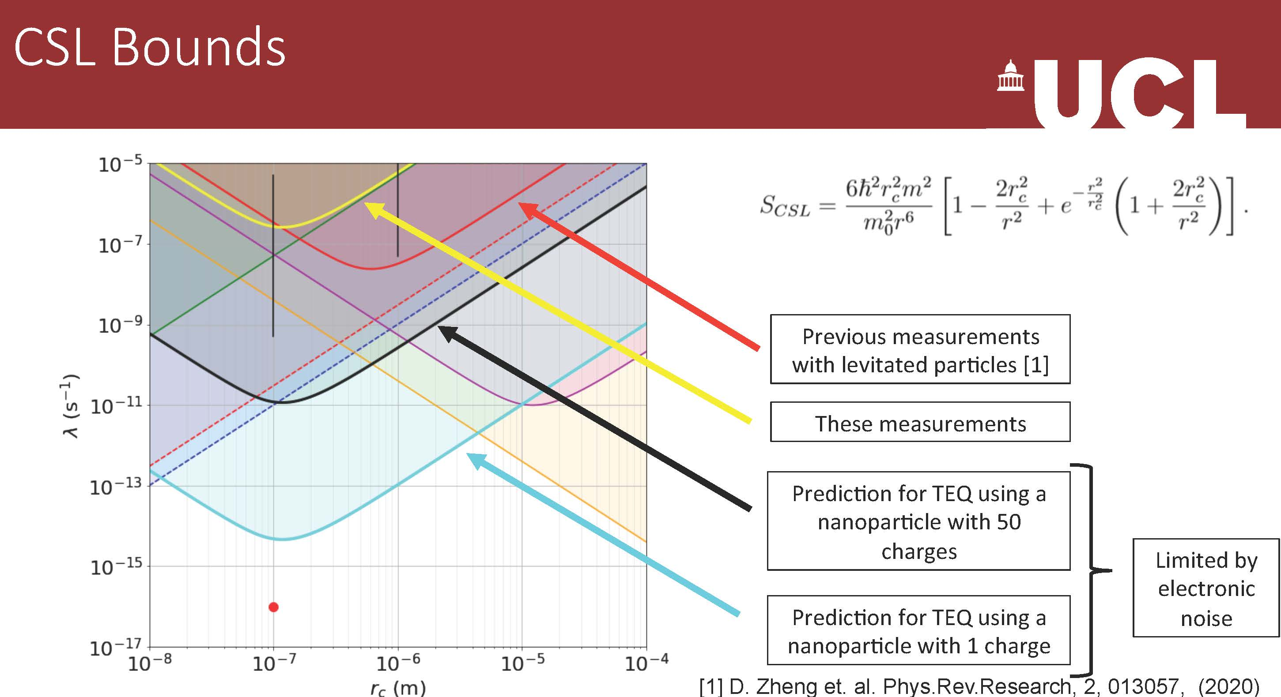to2): The Paul trap is now re-assembled to be tested with the new low noise electronics from INFN and in a condition which can then be mounted in the cryostat at UoS.

Figure 2: Room temperature experimental result from UCL with Paul trap and projection of 300 mK experiment. Unpublished results, not to spread further.

* To 3): A design for mounting the Paul trap in the cryo at UoS has been completed in discussion with all TeQ partners, **c.f. Fig.3.** The Paul trap will be mounted inside the UHV chamber and attached to the 300 mK plate, a vibration damper to work at trap frequency (100 Hz to 1 kHz) has been designed and is manufactured at the moment at Southampton (planned to be completed by end of January 2022). The loading of the trap will be done by a laser ablation technique (LIAD), which is now used by a number of groups in the community (Innsbruck, Vienna, KCL). The ablation laser (Yag, 2nd harmonic at 532 nm) has been purchased and delivered at UoS in December 2021. A project student has build a setup to test the LIAD technique to load a particle trap (loading tests will be conducted in January 2022). The particle in the Paul trap will be detected optically by using a parabolic mirror.

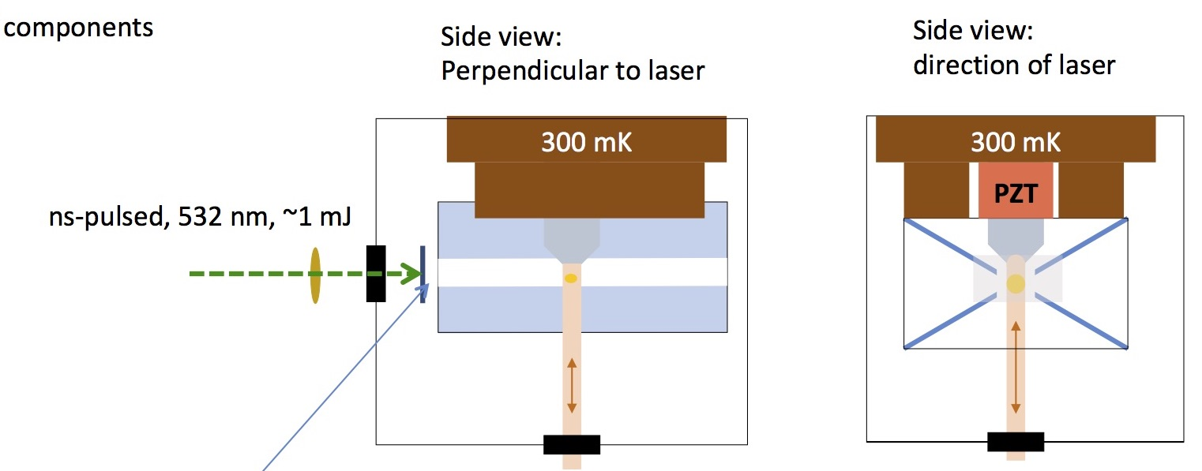

Figure 3: Trap design plan for 300 mK experiment with loading and optical detection.

* To 4): magnetic levitation experiment at UoS are underway. A new particle loading mechanism has been used to launch sub 60 micron particles based on the PIEZO. In order to achieve the TeQ objective (1e-11 Hz @ 1e-7m) we need to launch a particle of about 10 microns in diameter. This has not been achieved yet and to overcome surface forces is the main challenge. The plan is to use magnetic forces generated by currents through wires at the bottom of the trap, in addition to the mechanical PIEZO loader. This will be done in January 2022 and the following months.
* To 5): A model is under development to describe the single trajectory detection technique and to then simulate the detection at experimental parameters. This has been discussed between experimentalists and theoreticians from QUB, Aarhus, UCL and UoS. The model is based on earlier work by some of the TeQ members and are published in: Setter et al., Phys. Rev. **A 97**, 033822 (2018) and McMillen et al., Phys. Rev. A. **95**, 012132 (2017). Different operation modes will be investigated to reduce the measurement time and to efficiently extract the noise level to search for the CSL effect. Possibilities include to generate a large number of fast measurements (~1 s) after initialisation of the particle motion out of equilibrium and during the much slower relaxation or for quick re-initialisation to allow for a sample set at the exact same initial conditions. The model is planned to be completed in December 2021 and tested with real data in January 2022.

**Next steps:**

* to 1): at UCL to assemble 5 PCB electronic board in to boxes with inputs and outputs. To be completed in January 2022 by electronics engineer at UCL.
* To 2): some technical steps have to be taken: cleaning the blades and assemble at a distance which will allow for the optical detection in the cryo (1mm diagonal blade distance), attachment of electrodes according to the wire plan for the TeQ experiment. This will be completed in December 2021. Then another set of room temperature measurements will be taken, possibly already with the new trajectory based detection scheme from QUB. This will happen in January 2022.
* To 3): design of the optical detection will be completed and parts will be purchased (January & February 2022), the vibration damper will be manufactured and tested (January 2022), the Paul trap is planned to be assembled in the cryostat starting with February 2022, which leaves 3 months to complete the first Paul TeQ test at 300 mK.
* To 4): work on launch of small particles by different leading techniques will be done in January 2022. Tests are done at 4K and if launch is successful the trap will move into the 300 mK cryo.
* To 5): complete model and test with real data is planned for January 2022 and if successful to be used for UCL room temperature tests as well as for UoS 300 mK tests.

**Next meeting on experiments within TEQ:** weekly meetings will be continued in January 2022 (first meeting on 11/01/2022) and until the experiment has been assembled at UoS. Meetings will be held online.

*HU/17/12/2021*